--------------------------------------------------------------------------- ValueError Traceback (most recent call last) <ipython-input-10-812e1d776fc9> in <cell line: 17>() 15 X_spca = pickle.load(open("/content/drive/MyDrive/Phong_code_2019/data/X_umafall_spca.p", "rb")) 16 X_raw = pickle.load(open("/content/drive/MyDrive/Phong_code_2019/data/X_umafall_raw.p", "rb")) ---> 17 X = np.concatenate((X_spca, X_raw), axis=1) 18 19 y = pickle.load(open("/content/drive/MyDrive/Phong_code_2019/data/y_umafall_raw.p", "rb")) ValueError: all the input array dimensions except for the concatenation axis must match exactly, but along dimension 0, the array at index 0 has size 3680 and the array at index 1 has size 3685

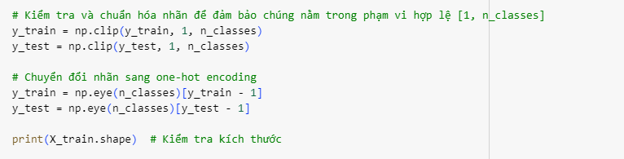

---------------------------------------------------------------------------

ValueError Traceback (most recent call last)

[<ipython-input-11-017c86c5f4fc>](https://localhost:8080/) in <cell line: 43>()

**68**

**69** # Đảm bảo X_train và X_test là float32

---> 70 X_train = np.array(X_train, dtype='float32')

**71** X_test = np.array(X_test, dtype='float32')

**72**

ValueError: could not convert string to float: '1.146.382.451.057.430'

